Setting up your online degree show profile and account
When you do any work on this site you will need to be logged in via Pulse Secure. The instruction on how to do this can be found at this link: https://ask.herts.ac.uk/vpn-virtual-private-network-and-pulse-secure
- Go to www.degreeshow.herts.ac.uk/postgrad2020
- At the top right-hand side of the page click on ‘Register’
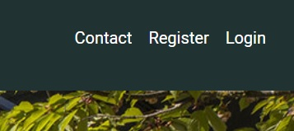

- Enter your ‘Full Name’.
- Enter your ‘email address’ (this will be the email address you will use to log on in the future).
- Enter ‘User Password’ (this is the password you will use to log on to this site).
- Confirm Password (this is a repeat of what you have just written as a user password).
- Click ‘Register.’
- Once you have successfully registered it will bring up the website homepage, where you will be able to access your portfolio.
- At the top right-hand side of the page click on ‘My Portfolio.’ This will bring up a welcome page. Please note the ‘Site Moderator’ will be your Programme Leader.
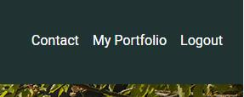
- At the top right-hand side of the page click on ‘Edit Portfolio’.
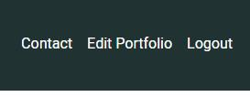
- Note: At any point during this process you will be able to ‘Save Draft’ or ‘Preview’ your profile. ‘Save Draft’ allows you to save your profile at its current point to work on later, ‘Preview’ allows you to see what your portfolio will look like on the website. We recommend that you save your draft after each section. N.B. you can only preview once you have accepted the ‘Terms and Conditions’ at the bottom of the page.
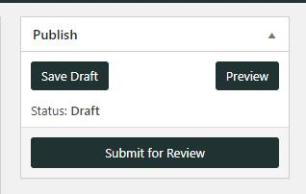
Profile Picture
This is the picture which people will see at the top of your profile page. This can be a picture of you or your brand.
Click on ‘Add Image.’

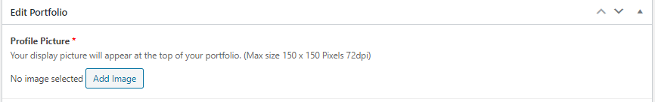
A new screen will appear called ‘select image.’ Make sure you are on the ‘upload files’ tab.
Click on ‘Select File.’
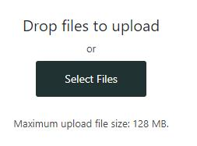
This will then allow you to select an image from your device.
The image needs to be 150 pixels by 150 pixels. To learn how to change your image size please click here. The image will automatically crop to the shape of the box on the page if you don’t select the correct pixel size.
Once you have selected an image, this will appear in your ‘Media Library’. Your ‘Media Library’ is where all your content will appear. Just click on the ‘Media Library’ tab to get here.
On the right-hand side of the screen you will see an ‘attachment details’ box, you can fill this in to help you navigate around your content once it is all uploaded. This box also allows you to permanently delete content which you have uploaded.
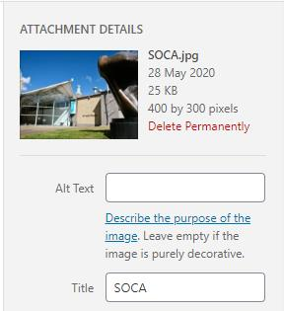
Once you have uploaded your picture and you are happy with the ‘attachment detail’ click the black ‘Select’ button on the bottom right hand corner.
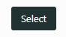

- Full Name
This will be the name at the top of your portfolio and will appear alongside your ‘feature Image’ (coming later).

- Course
Choose your course from the dropdown menu.
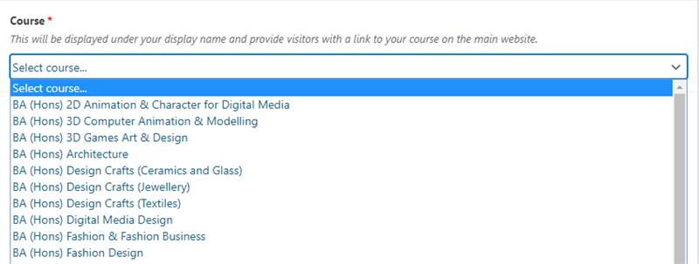

- Biography
This is a short biography, 250 characters max.
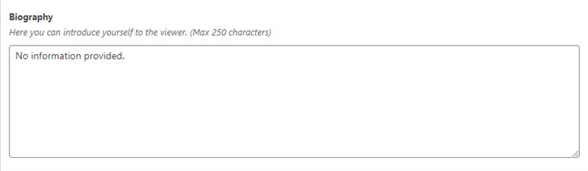
- Major Study Project Description Video
This is an opportunity for you to create a ‘video project explainer’ and link to it so that it appears on this website. It can be on platforms such as YouTube, Vimeo or Soundcloud. It is a way for you to introduce the viewer to your portfolio.
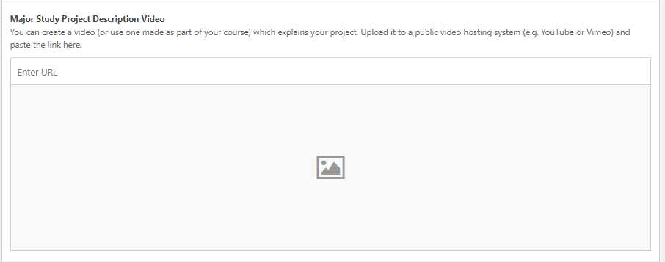
If you are not sure how to create your own video, please follow our guide on the CA Toolkit.

- Menu Image
This is the image that will appear on the homepage of the website, it should illustrate your project. Add an image in the same way as described above. N.B. At this point it will default to the ‘media library’ tab rather than the ‘upload files’ tab. If you wish to use this image again on your portfolio page, you will need to select it as one of your media images (see below).
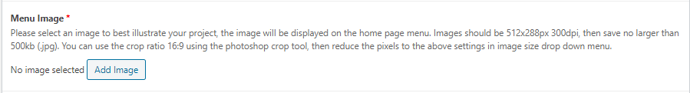

- Media Upload
This is where you can add content to your portfolio.
Click on the ‘add media’ button to the right-hand side of the pane.
This gives you the options to add an image or embed a video.

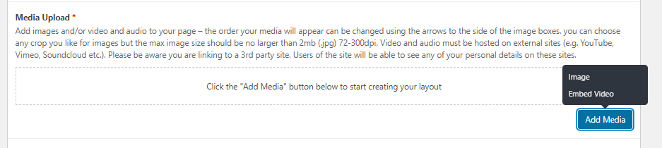If you want to add an image, click on ‘image.’
If you want to add a video, click on ‘embed video.’
You can embed up to three videos

If you want to adjust the order of your media, simply drag the entire pane into the position you desire.
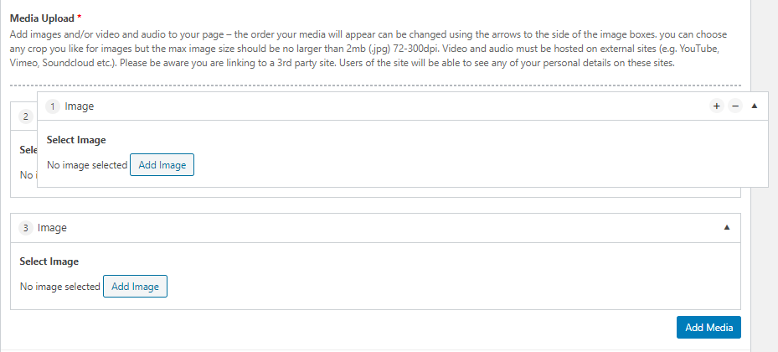
- URL to CV Link
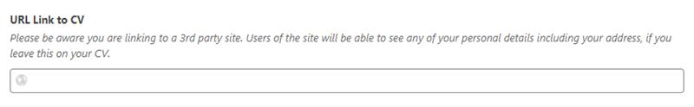
Note: If you are considering uploading a CV, please make sure that you do not include personal data you do not wish to share. Do not share your home address.
Note: Optional / you do not have to fill this in
- URL Link to Personal Blog
Note: Optional / you do not have to fill this in

- Website Portfolio
- 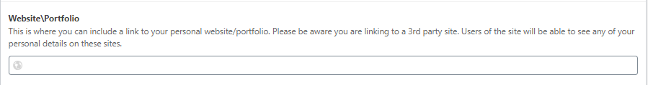
Note: Optional / you do not have to fill this in

- Email address
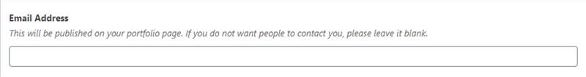
Note: Optional / you do not have to fill this in
Professional Profile Links

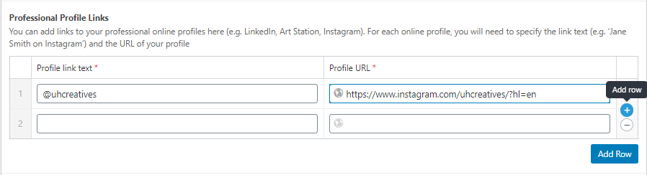
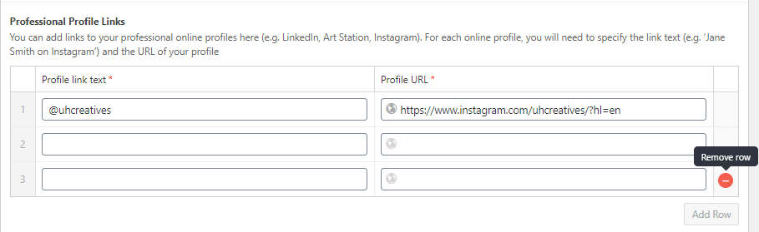
Note: Optional / you do not have to fill this in

- Terms and Conditions
Please tick the Terms and Conditions button once you have read the details
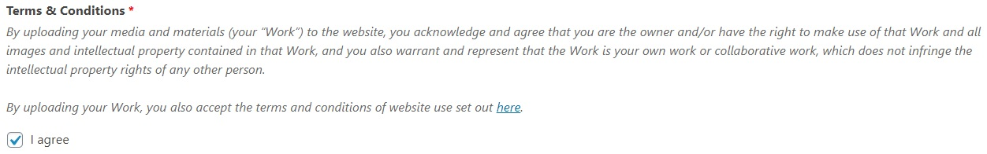

- Submit
You can now submit your portfolio for review by a moderator. Click the ‘submit for review’.